POST-GRADUATE
RESEARCH STUDENT
PERSONAL DEVELOPMENT PLAN

Welcome
Commencing a research degree means setting out on an adventure into the unknown. You have probably already given some considerable thought to your research project. What is the problem that you are investigating? Why does it matter? How will you investigate it? When will you complete the different components of the project? Perhaps even where you will publish the findings. But have you considered who will undertake this adventure? Of course, that is going to be you, the researcher.
If you are going to submit a good quality thesis in the time available to you, then you need to plan to develop your skills for this adventure with the same care as you invest in the other parts of your research. This is where the Personal Development Plan comes in. Bringing together the skills that you will need for your research project, and the skills that you need to achieve your career aspirations, it supports you in auditing the skills you already have and identifying your development needs. It suggests opportunities for building the desired skills and provides a means for recording and reflecting on development. I encourage you to make the most of the opportunities and training available to you during your research degree.
Professor Bryn Jones
Deputy Vice-Principal (Dubai)
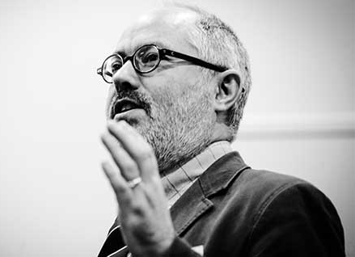
Postgraduate Research Degree Candidate Personal Development Plan
Postgraduate Research Degree Candidates are full members of the Heriot-Watt University community, supporting the Strategy 2025 themes of Excelling in ‘Research and Enterprise’ and ‘Inspiring Teaching’. Research Degree Candidates belong to our community. You will collaborate with your Supervisory Teams and other researchers. You will be inspired by and inspire others, and, as a community, we celebrate your successes.
To be awarded a Research Degree at Heriot-Watt University, PGR students must:
- Provide evidence of originality
- Demonstrate the discovery of new facts and/or exercise of critical powers
- Show evidence of sustained independent effort
- Present a satisfactory thesis and defend thesis in a viva
- Demonstrate full and proper understanding of the research methods appropriate to the field of study
(cf: https://www.hw.ac.uk/students/studies/examinations/thesis-examination.htm)
The Heriot-Watt University PGR Code of Practice sets out the expectations and responsibilities of Research Degree Candidates and their supervisors. Success in postgraduate research requires a sustained period of application and enquiry, conducted by Research Degree Candidates in a way which complies with best practice in research integrity, and is enabled by the provision of a qualified and supported Supervisory Team and an appropriate research environment.
Research Degree Candidates are required to participate in School and University Inductions, and transferable skills training courses. You are expected to assess your own training needs and create a Personal Development Plan (PDP), actively seeking out development opportunities in areas where your skills require enhancement. You should be able to demonstrate that you have undertaken at least 10 days per annum of skills training (pro-rata for part-time) during each year through submission of your PDP at Progress Review Meetings.
A PDP is a structured review and planning exercise which will help focus discussion with your supervisor. Your PDP will enable you to review and set development goals as you progress through your Research Degree. Many of the skills developed by Research Degree Candidates are also required in careers outside of academia, so planning your training needs and undertaking relevant and timely training will enable you to complete your research degree on time and will stand you in good stead for a career in academia and beyond.

Please refer to the PGR Code of Practice (https://www.hw.ac.uk/services/docs/learning-teaching/policies/cop-pgr.pdf) and the PGR Director in your School if you have any queries.

Research Futures Academy
Research Futures Academy provides an extensive programme of personal and professional training and development opportunities for postgraduate research (PGR) students at Heriot-Watt University to develop the essential skills Research Degree Candidates will require to succeed during their research degree.
These workshops are led by experienced internal and external facilitators, research leaders and subject experts to help you to succeed in your doctorate and prepare for your future career in research and beyond. Our workshops provide opportunities to network and share ideas with students and staff from the different Schools.
Research Futures Academy are increasing accessibility to attend workshops remotely and/or online to PGR students across all campuses in UK, Dubai, and Malaysia. For more information on upcoming workshops visit https://pdms.hw.ac.uk/.
During your PhD you are encouraged to make the most of the opportunities available to you at Heriot-Watt University through Research Futures Academy, HW Engage, HW Enterprise, Organisational Development, and your School.

Sign up to the monthly Research Futures Academy Newsletter to be kept up to date with any additional opportunities and events www.hw.ac.uk/researchfutures.
Researcher Development Framework
Vitae (www.vitae.ac.uk) is the global leader in supporting the professional development of researchers. Key attributes and behaviours of successful researchers are articulated in the “Researcher Development Framework” (RDF) below. This can be used to discuss and plan your personal development as a researcher whilst undertaking your doctoral studies. Research Futures Academy provision is mapped against the 4 domains of the RDF to enable you to identify which workshops which would be most useful for your needs.
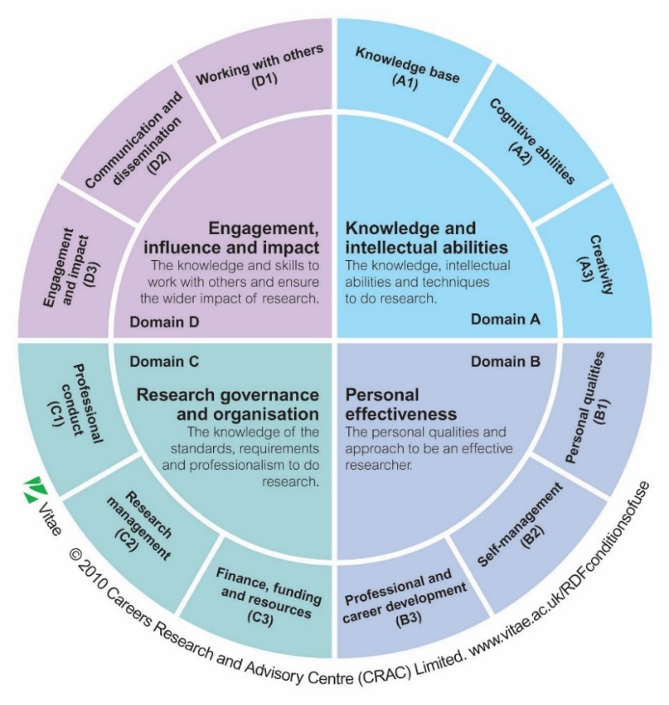
As Heriot-Watt University is an institutional member of Vitae, you have free access to additional Vitae content by creating an account using your Heriot-Watt University email address (https://www.hw.ac.uk/services/research-futures/resources/vitae-membership.htm)
The Researcher Development Framework (RDF)

Domain A – Knowledge and intellectual abilities
- e.g. Knowledge and skills required for research project; Analytical and critical thinking skills; Academic writing

Domain B – Personal effectiveness
- e.g. Professional development and self-confidence; Personal time management, networking, work-life balance; Management of professional and career opportunities
Domain C – Research governance and organisation
- e.g. Professional conduct and standards – ethics and legalities; Project management skills and strategy; Funding and financial management
Domain D – Engagement, influence and impact
e.g. Working with your supervisor and in a team; Research communication and dissemination; Public engagement and research impact
Developing your Personal Development Plan
FIRST YEAR
Things to consider:
- Read and understand Code of Practice - https://www.hw.ac.uk/services/docs/learning-teaching/policies/cop-pgr.pdf
- Understand expectations of supervisor and student
- Identify key events and milestones for your PhD
- Develop your Personal Development Plan with your supervisor
- Complete School and University level Inductions
- Write everything down – it will make writing your thesis much easier
Skill focus:
- Project management
- Time management
- Library skills
- Working with your supervisor
Recommended Research Futures Academy workshops:
- Getting Started Series
- Introduction to project management
Starting a Research Degree is an exciting time – take time to plan your research and development to ensure you don’t get overwhelmed. Remember you have 3-4 years – you don’t need to complete everything in your first year!
Read through the different stages of the research degree journey on the next few pages for tips on what you should be doing as you progress through your studies.
Remember that each Research Degree is unique and researchers will require different skills at different stages of their studies, so you should develop your own plan to ensure you have the skills required for your studies.
To develop your Personal Development Plan,
- Use the Training Needs Analysis on page 6 to reflect on your current skill level.
- Indicate how competent you are (i.e. very skilled, competent, needs development) for each skill – identify your strengths and skills you need to develop further.
- With your supervisor identify which skills are most relevant for the different stages of your PhD and develop your PDP plan for the next year.
- Identify appropriate training workshops offered by Research Futures Academy (See page 9), your School, or other development opportunities to improve your skill level.
- Review your training record at Annual Review and set new development goals for the next year.

MIDDLE YEAR(S)
Things to consider:
- Review your progress and adjust plan if necessary
- Reflect on your personal and professional development and achievements to date
- Write regularly to improve your academic writing skills
- Develop communication skills by presenting at conferences or taking part in 3 Minute Thesis
- Consider your career options post Research Degree now to give you time to develop additional skills that may be required
- Be part of the Heriot-Watt research community (i.e. Research Culture Grants)
Skill focus:
- Academic writing
- Communication

Recommended Research Futures Academy workshops:
- Presentation series
- Research Writing Series
- Writing your thesis
- Thesis Writing Retreat
FINAL YEAR
Things to consider:
- Write regularly to hone your academic writing skills
- Familiarise yourself with Guidelines on Submission and Format of Thesis at Heriot-Watt University - https://www.hw.ac.uk/students/studies/examinations/thesis.htm
- Know what to expect in a viva examination
- Apply for post-docs, fellowships and jobs
- Continue to develop your professional network
- Update CV
Skill focus:
- Academic writing
- Communication
- Publishing
Recommended Research Futures Academy workshops:
- Writing your thesis
- Preparing for your viva
- Publishing Research Series
- Careers beyond academia
The middle year(s) of a research degree can often be challenging, so don’t forget to reflect on your achievements and progress to date. Ensure you have a healthy work-life balance. Break your tasks down into realistic objectives to increase productivity.
Writing a thesis will take longer than you think. You should agree a realistic timeline for writing and redrafting your thesis with your supervisory team in your annual review. Ensure you know the standards and expectations of your thesis and viva early on.
Training Needs Analysis
Adapted from the Vitae Researcher Development Framework for PGR students.
Domain A: Knowledge and intellectual abilities
Skill | Competence | Required when | Action
Understanding of relevant research methods/techniques and application
Information seeking online and offline
Understanding of data management and security
Independent thinking about own research
Able to critically evaluate own work and previous work
Problem solving
Idea generation
Knowledge of appropriate software
Other:
Other:

Domain B: Personal effectiveness
Skill | Competence | Required when | Action
Demonstrates perseverance and resilience
Works to high levels of accuracy, organisation and attention to detail
Prepares and plans to meet objectives
Manages own time effectively
Maintains healthy work-life balance
Takes ownership of and manages own career progression (PDP)
Awareness of potential career paths in and out of academia
Shows initiative and works independently
Able to articulate transferable skills developed during research degree
Able to work effectively as a team
Other:
Other:
Domain C: Research governance and organisation
Skill | Competence | Required when | Action
Understanding of relevant health and safety rules
Understanding of standards of good research practice
Understanding of guidelines for ethical conduct of research and legal requirements
Understanding of data protection and confidentiality
Able to reference material accurately
Able to manage citations and create bibliography using reference management software
Able to check original work for plagiarism
Project planning, organisation, execution and evaluation
Project management
Able to prioritise tasks and balance multiple demands
Setting and meeting milestones and intermediate goals
Understanding of the funding process for research
Awareness of relevant University systems and procedures
Other:
Other:

Domain D: Engagement, influence and impact
Skill | Competence | Required when | Action
Works effectively with supervisor
Knowledge on how to produce a coherent, concise and well-written report
Understanding of the publication process
Able to communicate research orally to diverse audiences
Able to produce and use effectively presentation slides
Able to articulate ideas and construct coherent arguments
Understanding of a professional social media presence
Awareness of the impact of research project on wider society
Development of professional network (inside and outside university)
Able to defend research findings effectively
Other:
Other:

Research Futures Academy Core Workshops Mapped to RDF
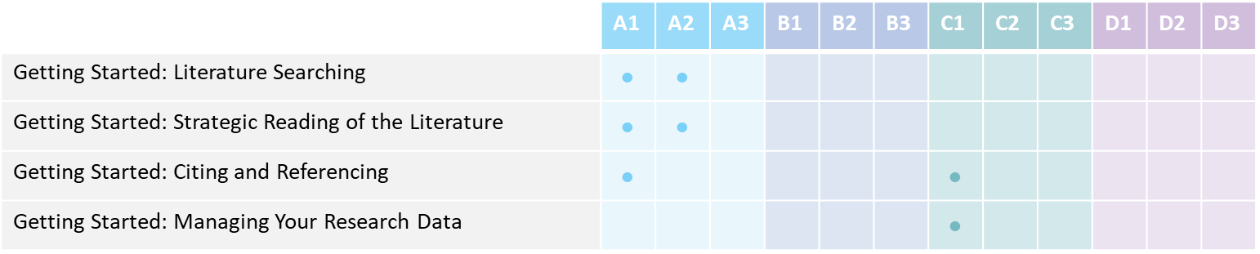
Additional training opportunities from Research Futures Academy will be communicated in our monthly Newsletter (www.hw.ac.uk/researchfutures) or may be available through your School or professional network.
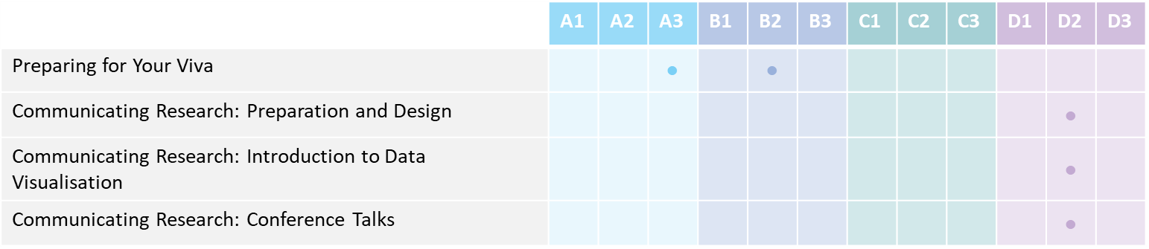
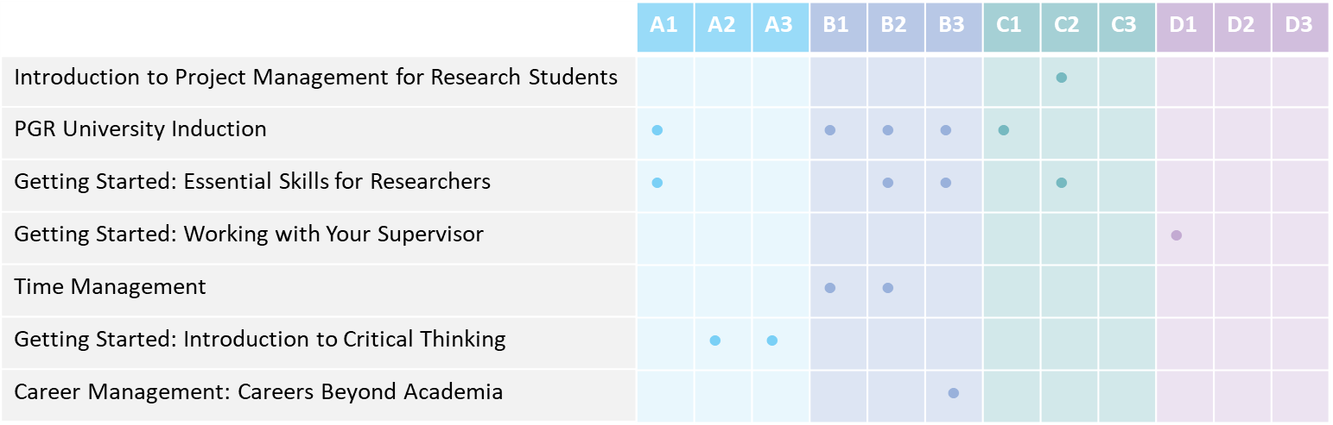
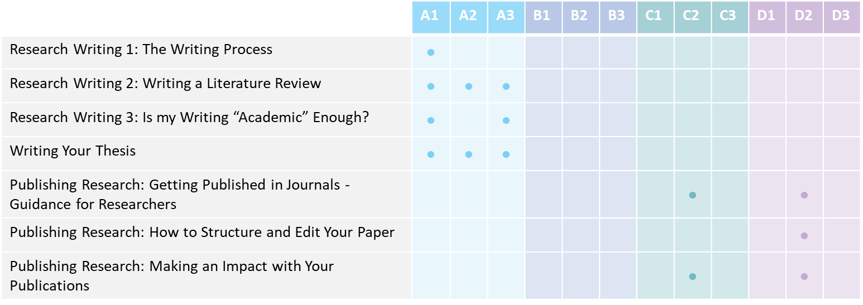

Skill | Action | By when
1st Year Action Plan

Action plan agreed on (date) _____________________
Student: _______________________ Supervisor: ____________________________
Reflect on progress (To be completed at Annual Review)

Skill | Action | By when
2nd Year Action Plan

Action plan agreed on (date) _____________________
Student: _______________________ Supervisor: ____________________________
Reflect on progress (To be completed at Annual Review)

Skill | Action | By when
3rd Year Action Plan

Action plan agreed on (date) _____________________
Student: _______________________ Supervisor: ____________________________
Reflect on progress (To be completed at Annual Review)

Skill | Action | By when
4th Year Action Plan

Action plan agreed on (date) _____________________
Student: _______________________ Supervisor: ____________________________
Reflect on progress (To be completed at Annual Review)

Personal Researcher Development Log
Name: __________________________
This development log should be updated as you undertake training throughout your research degree. You can use this as evidence of undertaking 10 days development training per year during your annual progress review.
Using the table below, indicate the relevant training undertaken and the dates. You should note what you learnt and the skills developed for future reference (e.g. annual review, interviews).
Record of attendance at training courses
Date(s) of training | Hours | Workshop/Event | Learning outcomes  Briefly, reflect on what you learnt and skills developed

Record of attendance at conferences and symposia
Date(s) of training | Hours | Conference/Symposia/  Seminar | Learning outcomes  Briefly, reflect on how this has supported your development as a researcher

Record of learning and networking opportunities (e.g. research visit, field work, consultation, industry visit)
Date(s) | Hours | Activity | Learning outcomes  Briefly, reflect on how this has supported your development as a researcher

