# Updating Language Preferences in Microsoft Word

Open Microsoft Word and choose ‘Blank document’ under ‘New’.

In the toolbar, select ‘Review’, then ‘Language’, followed by ‘Language Preferences’ from the drop-down menu.

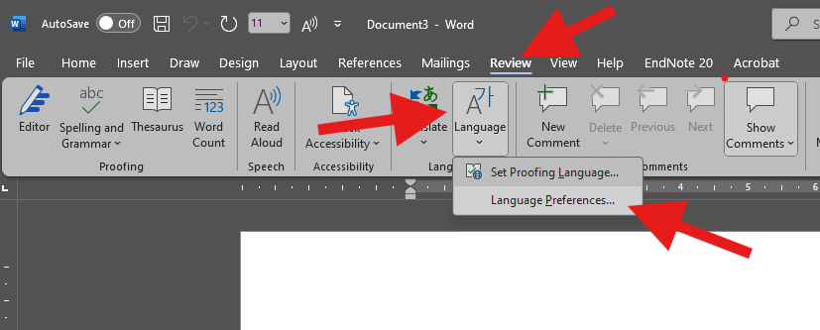

In the resulting pop-up window, under **Office authoring languages and proofing**, select ‘Add a language’.

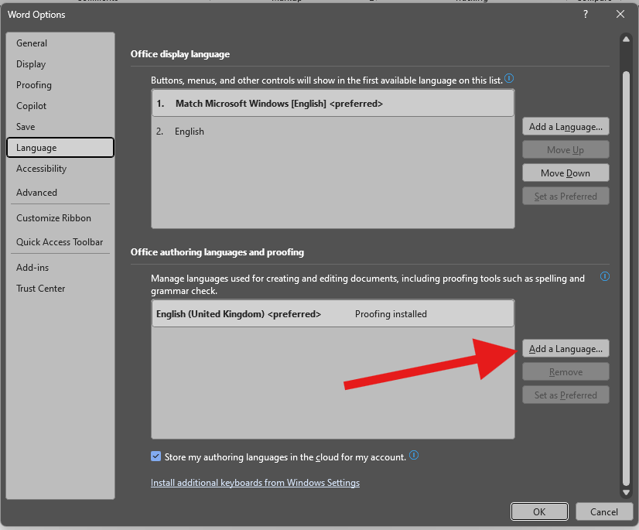

In the resulting pop-up window, choose the required languages and choose **ADD** and click **OK.**

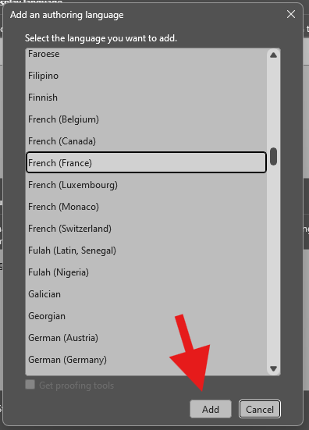

Restart Microsoft Word.

On restarting and choosing blank document, the user should now see a language option at bottom of screen.



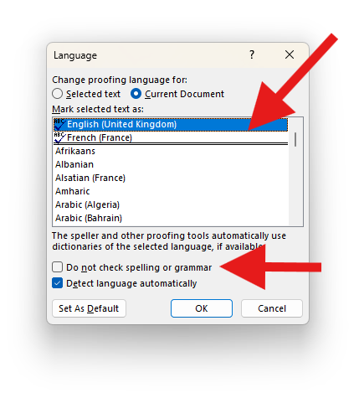Clicking this brings up a language choice window where the user can switch between different languages and also has the option of Do no check spelling or grammar if desired.  
Additionally if the user wishes to alter Autocorrect options, they can do this by choosing ‘File’ in the toolbar, and then ‘Options’ at the bottom left of the screen. Under ‘Proofing’ in the side bar menu, they should see all the AutoCorrect options they might want to turn on/off.

